# 

**Introduction to the Linux Commandline**

Date: September 27., 2012, EMBL Heidelberg

Authors: Holger Dinkel & Frank Thommen  
Structural and Computational Biology Unit

Version: 1.0

## Why Use the Commandline

* It's **fast**. Productivity is a word that gets tossed around a lot by so-called power users, but the command line can really streamline your computer use, assuming you learn to use it right.
* It's **easier to get help**. The command line may not be the easiest thing to use, but it makes life a whole lot easier for people trying to help you and for yourself when looking for help, especially over the internet. Many times it's as simple as the helper posting a few commands and some instructions and the recipient copying and pasting those commands. Anyone who has spent hours listening to someone from tech support say something like, “OK, now click this, then this, then select this menu command” knows how frustrating the GUI alternative can be.
* It's nearly **universal**. There are hundreds of Linux distros out there, each with a slightly different graphical environment. Thankfully, the various distros do have one common element: the command line. There are distro-specific commands, but the bulk of commands will work on any Linux system.
* It's **powerful**. The companies behind those other operating systems try their best to stop a user from accidentally screwing up their computer. Doing this involves hiding a lot of the components and tools that could harm a computer away from novices. Linux is more of an open book, which is due in part to its prominent use of the command line.

## General Remarks Regarding Using UNIX/Linux Systems

* **Test before run**. Anything written here has to be taken with a grain of salt. On another system – be it a different Linux distribution or another UNIXoid operating system – you might find the same command but without the support of some of the options tought here. It is even possible, that the same option has a different meaning on another system. With this in mind always make sure to test your commands (specially the “dangerous” ones which remove or modify files) when switching from one system to the other.
* **The Linux/UNIX environment**. The behaviour of many commands is influenced or controlled by the so-called “environment”. This environment is the sum of all your environment variables. Some of these environment variables will be shown towards the end of this course.
* **UPPERCASE, lowercase**. Don’t forget that everything is case-sensitive.
* **The Filesystem**. Linux filesystems start on top at the root directory (sic!) “/” which hierarchically broadens towards the ground. The separator between directories or directories and files in Linux is the slash (“/”).  
  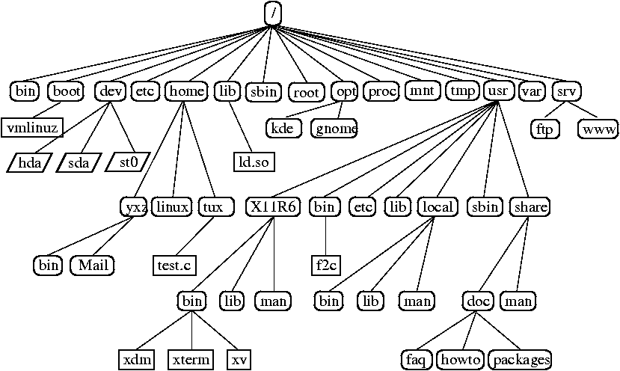  
  Depending on the Linux distribution you might or might not find all of above directories. Most important directories for you are /bin and /usr/bin (sometimes also /usr/local/bin) which contain the user software, /home which usually contains the users’ homedirectories and /tmp which can be used to store temporary data (beware: Its content is regularly removed!).

Note: The terms “directory” and “folder” are used interchangeably in this document.

## General Structure of Linux Commands

Linux commands have the following general structure:

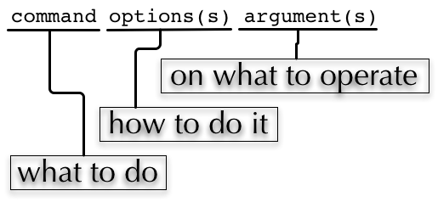

commandline options (sometimes called comandline switches) commonly have one of the two following forms: The short form -*character* or the long form --*string*. E.g.

man -h

man --help

Short options are usually – though not always – concatenable:

ls -l -A -h

ls -lAh

Some options require an additional argument, which is added with a blank to the short form and with an equal sign to the long form:

ls -I “*.pdf”

ls --ignore=”*.pdf”

Since Linux incorporates commands from different sources, options can be available in one or both forms and you’ll also encounter options with no dash at all and all kinds of mixtures:

tar cf file.tar -C .. file/

ps auxgww

## A Journey Through the Commands

Please note that all examples and usage instructions below are just a glimpse of what you can do and reflect our opinion on what’s important and what’s not. Most of these commands support many more options and different usages. Consult the manpages to find them.

Typographical conventions: Commands and examples are written in Courier. User Input is written in **Courier bold** and placeholders are generally written in *italic*.

### Getting Help

-h/--help option, no parameters

Many commands support a “help” option, either through -h or through --help. Other commands will show a help page or at least a short usage overview if you provide wrong commandline options

man – show the manual page of a command

Usage: man command

# **man man**

man(1) man(1)

NAME

man - format and display the on-line manual pages

SYNOPSIS

man [-acdfFhkKtwW] [--path] [-m system] [-p string] [-C config_file]

[...]

#

For the navigation within a manpage see the chapter regarding less below.

|  |  |
| --- | --- |
|  | The behaviour of man is dependent of the $PAGER environment variable |

apropos – list manpages containing a keyword in their description

Usage: apropos *keyword*

# **apropos who**

[...]

who (1) - show who is logged on

who (1p) - display who is on the system

whoami (1) - print effective userid

#

Use this to find candidates for specific tasks

/usr/share/doc

The /usr/share/doc directory in some Linux distributions contains additional documentation of installed software packages

### Where am I, who am I

whoami – Print your username

Usage: whoami

# **whoami**

fthommen

#

hostname – Print the name of the computer

Usage: hostname

# **hostname**

pc-teach01

#

pwd – Print the current working directory

Usage: pwd

# **pwd**

/home/fthommen

#

date – Print current date and time

Usage: date

# **date**

Tue Sep 25 19:57:50 CEST 2012

#

|  |  |
| --- | --- |
|  | The command time does something completely different and is not used to show the current time. |

### Moving Around

cd – Change the working directory

Usage: cd [new_directory]

# **pwd**

/home/fthommen

# **cd /usr/bin**

# **pwd**

/usr/bin

#

Special directories:  
“.”: The current working directory  
“..”: The parent directory of the current working directory  
“~”: Your homedirectory

|  |  |
| --- | --- |
|  | Using cd without a directory is equivalent to “cd ~” and changes into the users’s homedirectory |
|  | Please note the difference between absolute pathes (starting with “/”) and relative pathes (starting with a directory name) |

# **pwd**

/usr

# **cd /bin**

# **pwd**

/bin

#

# **pwd**

/usr

# **cd bin**

# **pwd**

/usr/bin

#

### See What’s Around

ls – List directory contents

Usage: ls [options] [file(s) or directory/ies]

# **ls**

/home/fthommen

# **ls –l aa.pdf**

-rw-r--r-- 1 fthommen cmueller 0 Sep 24 10:59 aa.pdf

#

Useful options:

-l: Long listing with permissions, user, group and last modification date

-1: Print listing in one column only

-a: Show all files (hidden, “.” and “..”)

-A: Show almost all files (hidden, but not “.” and “..”)

-F: Show filetypes (nothing = regular file, “/” = directory, “*” = executable file, “@” = symbolic link)

-d: Show directory information instead of directory content

-t: Sort listing by modification time (most recent on top)

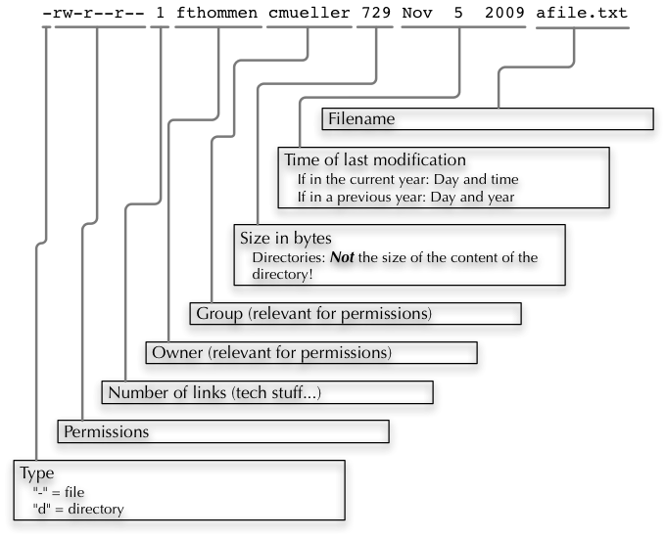

Digression: Shell globs

Files and folders can’t only be referred to with their full name, but also with so-called “Shell Globs”, which are a kind of simple pattern to address groups of files and folders. Instead of explicit names you can use the following placeholders:

?: Any single character

*: Any number of any character (including no character at all)

[…]: One of the characters included in the brackets. Use “-“ to define ranges of characters

Examples:

*.pdf: All files having the extension “.pdf”

?.jpg: Jpeg file consisting of only one character

[0-9]*.txt: All files starting with a number and having the extension “.txt”

*.???: All files having a three-character extension

|  |  |
| --- | --- |
|  | The special directory “~” mentioned above is a shell glob, too. |

### Organize Files and Folders

touch – Create a file or change last modification date of an existing file

Usage: touch file(s) or directory/ies

# **ls afile**

ls: afile: No such file or directory

# **touch afile**

# **ls afile**

afile

#

# **ls –l aa.pdf**

-rw-r--r-- 1 fthommen cmueller 0 Sep 24 10:59 aa.pdf

# **touch aa.pdf**

# **ls –l aa.pdf**

-rw-r--r-- 1 fthommen cmueller 0 Sep 25 22:01 aa.pdf

#

rm – Remove files and directories

Usage: rm [options] file(s)

rm –r [options] directory/ies

# **ls afile**

afile

# **rm afile**

# **ls afile**

ls: afile: No such file or directory

#

Useful options:

-i: Ask for confirmation of each removal

-r: Remove recursively

-f: Force the removal (no questions, no errors if a file doesn't exist)

|  |  |
| --- | --- |
|  | rm *without* the –i option will usually ***not*** ask you if you really want to remove the file or directory |

mv – Move and rename files and folders

Usage: mv [options] sourcefile destinationfile

mv [options] sourcefile(s) destinationdirectory

# **ls *.txt**

a.txt

# **mv a.txt b.txt**

# **ls *.txt**

b.txt

#

Useful options:

-i: Ask for confirmation of each removal

|  |  |
| --- | --- |
|  | You cannot overwrite an existing directory by another one with mv |

mkdir – Create a new directory

Usage: mkdir [options] directory

# **ls adir/**

ls: adir/: No such file or directory

# **mkdir adir**

# **ls adir**

#

Useful options:

-p: Create parent directories (when creating nested directories)

# **mkdir adir/bdir**

mkdir: cannot create directory `adir/bdir': No such file or directory

# **mkdir –p adir/bdir**

#

rmdir – Remove an empty directory

Usage: rmdir directory

# **rmdir adir/**

#

|  |  |
| --- | --- |
|  | If the directory is not empty, rmdir will complain and ***not*** remove it |

cp – Copy files and folders

Usage: cp [options] sourcefile destinationfile

cp [options] sourcefile(s) destinationdirectory

# **cp P12931.fasta backup_of_P12931.fasta**

#

Useful options:

-r: Copy recursively

-i: Interactive operation, ask before overwriting an existing file

-p: Preserve owner, permissions and timestamp

### View Files

cat – Print files on terminal (concatenate)

Usage: cat [options] file(s)

# **cat P12931.fasta backup_of_P12931.fasta**

[...]

#

|  |  |
| --- | --- |
|  | cat only makes sense for short files or for e.g. combining several files into one. See the redirection examples later |

less – View and navigate files

Usage: less [options] file(s)

# **less P12931.fasta backup_of_P12931.fasta**

[...]

#

|  |  |
| --- | --- |
|  | This is the default “pager” for manpages under Linux unless you redefine your $PAGER environment variable |

**Navigation within less:**

up, down, right, left: use cursor keys

top of document: g

bottom of document: G

search: “/” + search term

find next match: n

find previous match: N

quit: q

### Extracting Informations from Files

grep – Find lines matching a pattern in textfiles

Usage: grep [options] pattern file(s)

# **grep -i ensembl P04637.txt**

DR Ensembl; ENST00000269305; ENSP00000269305; ENSG00000141510.

DR Ensembl; ENST00000359597; ENSP00000352610; ENSG00000141510.

DR Ensembl; ENST00000419024; ENSP00000402130; ENSG00000141510.

DR Ensembl; ENST00000420246; ENSP00000391127; ENSG00000141510.

DR Ensembl; ENST00000445888; ENSP00000391478; ENSG00000141510.

DR Ensembl; ENST00000455263; ENSP00000398846; ENSG00000141510.

#

Useful options:

-v: Print lines that do *not* match

-i: Search case-insensitive

-l: List files with matching lines, not the lines itself

-L: List files without matches

-c: Print count of matching lines for each file

head – Print first lines of a textfile

Usage: head [options] file(s)

# **head /etc/passwd**

root:x:0:0:root:/root:/bin/bash

bin:x:1:1:bin:/bin:/sbin/nologin

daemon:x:2:2:daemon:/sbin:/sbin/nologin

adm:x:3:4:adm:/var/adm:/sbin/nologin

lp:x:4:7:lp:/var/spool/lpd:/sbin/nologin

sync:x:5:0:sync:/sbin:/bin/sync

shutdown:x:6:0:shutdown:/sbin:/sbin/shutdown

halt:x:7:0:halt:/sbin:/sbin/halt

mail:x:8:12:mail:/var/spool/mail:/sbin/nologin

news:x:9:13:news:/etc/news:

#

Useful options:

-n *num*: Print *num* lines (default is 10)

tail – Print last lines of a textfile

Usage: tail [options] file(s)

# **tail –n 3 /etc/passwd**

xfs:x:43:43:X Font Server:/etc/X11/fs:/sbin/nologin

gdm:x:42:42::/var/gdm:/sbin/nologin

sabayon:x:86:86:Sabayon user:/home/sabayon:/sbin/nologin

#

Useful options:

-n *num*: Print *num* lines (default is 10)

-f: “Follow” a file (print new lines as they are written to the file)

### Useful Filetools

file – determine the filetype

Usage: file [options] file(s)

# **file /bin/date**

/bin/date: ELF 32-bit LSB executable

# **file /bin**

/bin: directory

# **file SRC_HUMAN.fasta**

SRC_HUMAN.fasta: ASCII text

#

The command file uses certain tests and some magic to determine the type of a file

which – find a (executable) command

Usage: which [options] command(s)

# **which date**

/bin/date

# **which eclipse**

/usr/bin/eclipse

#

find – search/find files in any given directory

Usage: find [starting path(es)] [search filter]

# **find /etc**

/etc

/etc/printcap

/etc/protocols

/etc/xinetd.d

/etc/xinetd.d/ktalk

[...]

#

find is a powerful command with lots of possible search filters. Refer to the manpage for a complete list. Examples:

Find by name:

# **find . -name SRC_HUMAN.fasta**

./SRC_HUMAN.fasta

#

Find by size: List those entries in the directory /usr/bin that are bigger than 500kBytes:

# **find /usr/bin -size +500k**

/usr/bin/oparchive

/usr/bin/kiconedit

/usr/bin/opjitconv

[...]

#

Find by type (d=directory, f=file, l=link)

# **find . -type d**

.

./adir

#

### Useful Terminal Tools

clear – Clear the “screen”

Usage: clear

# **clear**

#

In case the output of the terminal/screen gets cluttered, you can use clear to clear the screen…

If this doesn't work, you can use reset to perform a re-initialization of the terminal:

reset – Reset your terminal

Usage: reset [options]

# **reset**

#

### Permissions

using ls -l to view entries of current directory:

# **ls –l**

drwxr-xr-x 2 dinkel gibson 4096 Sep 17 10:46 adir

lrwxrwxrwx 1 dinkel gibson 15 Sep 17 10:45 H1.fasta -> H2.fasta

-rw-r--r-- 1 dinkel gibson 643 Sep 17 10:45 H2.fasta

#

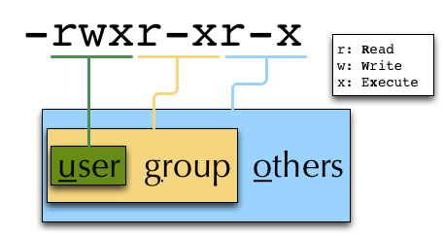

#### Changing Permissions

Permissions are set using the chmod (**ch**ange **mod**e) command.

Usage: chmod [options] mode(s) files(s)

# **ls –l adir**

drwxr-xr-x 2 dinkel gibson 4096 Sep 17 10:46 adir

# **chmod u-w,o=w adir**

# **ls –l adir**

dr-xr-x-w- 2 dinkel gibson 4096 Sep 17 10:46 adir

#

The mode is composed of

|  |  |  |  |  |
| --- | --- | --- | --- | --- |
| Who |  | What |  | Which permission |
| u: user/owner  g: group  o: other  a: all |  | +: add this permission  -: remove this permission  =: set exactly this permission |  | r: read  w: write  x: execute |

Add e**x**ecutable permission to the group:

# **chmod g+x file**

#

Revoke this permission:

# **chmod g-x file**

#

Allow **a**ll to read a directory:

# **chmod a+rx adir/**

#

### Remote access

To execute commands at a remote machine/server, you need to log in to this machine. This is done using the **ssh** command (**s**ecure **sh**ell).

In its simplest form, it takes just the machinename as parameter (assuming the username on the local machine and remote machine are identical):

# **ssh *remote_server***

|  |  |
| --- | --- |
|  | Once logged in, use hostname, whoami, etc. to determine on which machine you are currently working! |

To use a different username, you can use either:

# **ssh *username*@*remote_server***

or

# **ssh -l *username* *remote_server***

When connecting to a machine for the first time, it might display a warning:

# ssh **sub-master**

The authenticity of host 'sub-master (10.11.4.84)' can't be established. RSA key fingerprint is 47:a4:0f:7b:c2:0f:ef:91:8e:65:fc:3c:f7:0c:53:8d. Are you sure you want to continue connecting (yes/no)?

Type **yes** here.

|  |  |
| --- | --- |
|  | If this message appears a second time, you should contact your IT specialist… |

To **disconnect** from the remote machine, type:

# **exit**

Copying files to and from remote computers can be done using **scp** (**s**ecure **c**o**p**y). The order of parameters is the same as in cp: first the name of the source, then the name of the destination. Either one can be the remote part

# **scp localfile server:/remotefile**

# **scp server:/remotefile localfile**

An alternative username can be provided just as in **ssh**:

# **scp username@server:/remotefile localfile**

## IO and Redirections

### Redirect

Redirect the output of one program into e.g. a file: (**Caution**: you can easily overwrite files by this!)

Inserting the current date into a new file:

# **date > *file_containing_date***

Filtering lines containing the term “src” from FASTA files and inserting them into the file lines_with_src.txt:

# **cd /exercises/**

# **grep -i "src" *.fasta > lines_with_src.txt**

### Append

Append something to a file (rather than overwriting it):

# **date >> file_containing_date**

#

### Pipe

Use the pipe symbol (|) to feed the output of one program into the next program. Here: use ls to show the directory contents and then use grep to only show those that contain fasta in their name:

# **cd /exercises**

# **ls | grep fasta**

EPSINS.fasta

FYN_HUMAN.fasta

P12931.fasta

SRC_HUMAN.fasta

#

## Environment Variables

Environment variables are a set of dynamic named values that can affect the way running processes will behave on a computer.

$HOME

Contains the location of the user's home directory. Although the current user's home directory can also be found out through the C functions getpwuid and getuid, $HOME is often used for convenience in various shell scripts (and other contexts).

|  |  |
| --- | --- |
|  | Do not change this variable unless you have a good reason and you know what you are doing! |

$PATH

Contains a colon-separated list of directories that the shell searches for commands that do not contain a slash in their name (commands with slashes are interpreted as file names to execute, and the shell attempts to execute the files directly).

$PAGER

This variable contains the path to the program used to list the contents of files through (such as less or more).

$PWD

This variable points to the current directory. Equivalent to the output of the command “pwd” when called without arguments.

### Displaying environment variables:

Use “echo” to display individual variables or “set” or “env” to view all at once:

# **echo $HOME**

/localhome/teach01

# **set**

**…**

**# env**

**…**

### Setting an environment variable:

Use “export” followed by the variable name and the value of the variable (separated by the equal sign) to set an environment variable:

# **export PAGER=/usr/bin/less**

|  |  |
| --- | --- |
|  | An environment variable is only valid for your current session. Once you logout of your current session, it is lost or reset. |

## About Bio-IT

Bio-IT is a community project aiming to develop and strengthen the bioinformatics user community at EMBL Heidelberg. It is made up of members across the different EMBL Heidelberg units and core facilities. The project works to achieve these aims, firstly, by providing a forum for discussing and sharing information and ideas on computational biology and bioinforamtics, focused on the Bio-IT portal http://bio-it.embl.de. Secondly, we organise and participate in a range of differnet networking and social activites aiming to strengthen ties across the community.

## Links and Further Informations

* A full 500 page book about the Linux commandline for free(!): LinuxCommand.org (http://linuxcommand.org/)
* Another nice introduction: “A beginner's guide to UNIX/Linux” (http://www.mn.uio.no/astro/english/services/it/help/basic-services/linux/guide.html)
* The “commandline starter” chapter of an O’Reilly book: Learning Debian GNU/Linux – Issuing Linux Commands (http://oreilly.com/openbook/debian/book/ch04_01.html)
* A nice introduction to Linux/UNIX file permissions: “chmod Tutorial” (http://catcode.com/teachmod/)
* Linux Cheatsheets (http://www.cheat-sheets.org/#Linux)
* For the technically interested:  
  Linux Filesystem Hierarchy Standard (http://www.pathname.com/fhs/) and Linux Standard Base (http://www.linuxfoundation.org/collaborate/workgroups/lsb)

## Acknowledgements

EMBL Logo © EMBL Heidelberg

Bio-IT Logo © Bio-IT Project. EMBL Heidelberg

Graphic of the Linux Filesystem on page 3 from the SuSE 9.2 manual © Novell Inc.

All other graphics Frank Thommen, EMBL Heidelberg

## Index

|

| 13

~

~ 5, 7

$

$HOME 13

$PAGER 4, 9, 13

$PATH 13

$PWD 14

A

Append 13

apropos 4

C

cat 8

cd 5

chmod 12

clear 11

cp 8

D

date 5

E

echo 14

env 14

Environment Variables 13

Environment Variables, Display 14

Environment Variables, Set 14

exit 13

export 14

F

file 10

find 10

G

grep 9

H

head 9

hostname 5

L

less 9

less, navigation 9

ls 6

M

man 4, 9

manpage 9

mkdir 8

mv 8

P

Permissions 11, 12

Permissions, change 12

Pipe 13

pwd 5, 14

R

Redirect 13

Remote access 12

reset 11

rm 7

rmdir 8

S

set 14

Shell globs 7

**ssh** 12

T

tail 10

touch 7

W

which 10

whoami 5